VacationPy

Humidity Heatmap Screen Shot

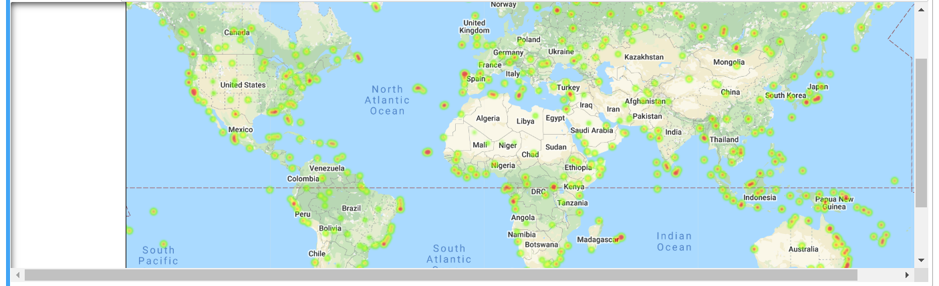

Screen Shot of Hotel Selections

